INSTR F343

**Mid-sem Report**

Stirred Tank Heater Process: Variable Holdup

horizontal line

# 

# Introduction

The Stirred Tank Heater is a device used to maintain a constant temperature outflow from a tank, when an input of variable rate of flow and temperature is provided. It is a vital factor of many chemical industries.Keeping the volume and temperature of the liquid in the tank is an essential task for the chemical process. It is usually paired with a flow controller in fluid processing plants and in pollution control plants to alter the temperature of the neutralized discharge post treatment, before it is released.

## Principle

The term “variable holdup” refers to the changing level of liquid in the tank, the outflow rate is maintained at a constant rate, while the inflow varies with time in unpredictable ways. A feedback loop controls the tank’s temperature by varying the rate of flow in the outlet. The heart of the process is an Integral Controller which is chosen since it allows for easy elimination of the offsets (additions or reductions to volume due to fluctuations in inflow rate). An Integral controller as we know, retains the offset taken during operation, which works to our advantage, since some liquid volume is retained or lost after a change in inflow rate before the outflow changes. The variables and equations involved in the modelling of this system are as shown below:

**Process Modelling**

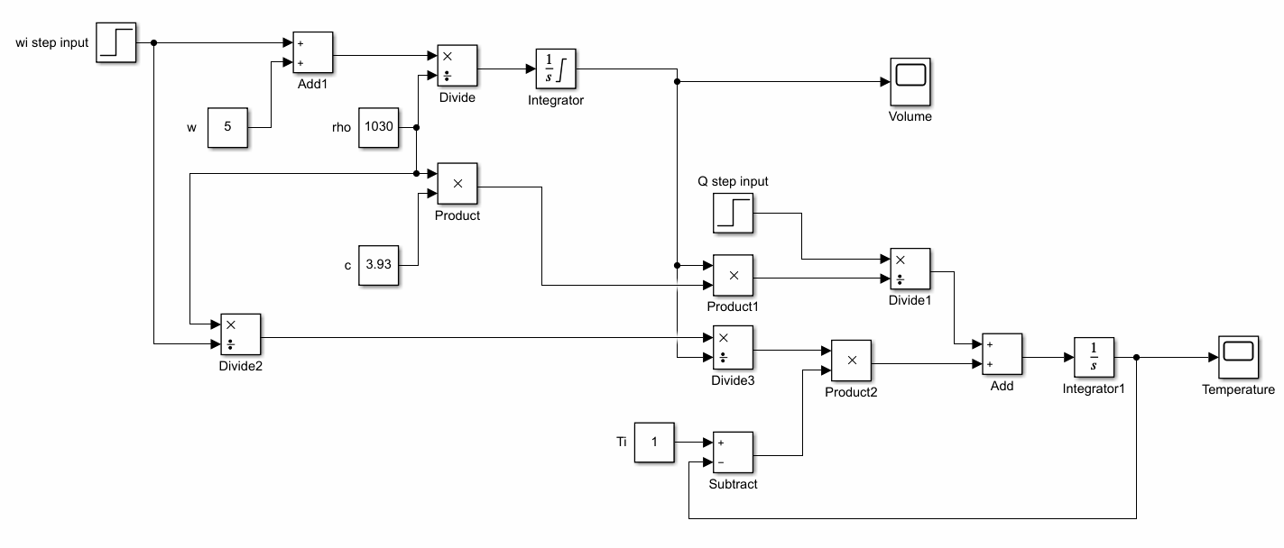

According to the Degrees of Freedom analysis,

Nv = number of process variables = 6 [wi, w, Q, Ti, V, T]

Ne = number of independent equations =2 [outputs: V, T]

Nf = degrees of freedom = Nv-Ne = 4

Since Nf>0, the system is underspecified. Hence we model the 4 other variables as inputs [wi, Q] and disturbances [w, Ti]

The laws of conservation of mass and energy are applied to the continuous stirred tank heater with a variable holdup.

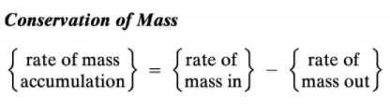

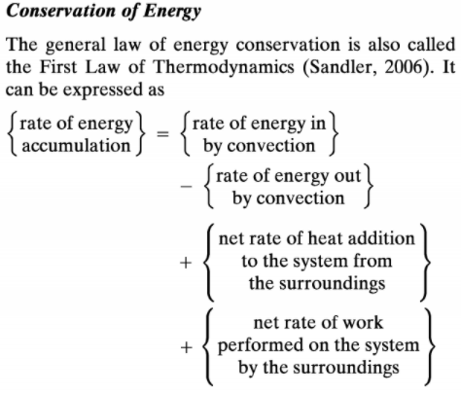

The differential equations thus derived are translated into the frequency domain using Laplace transformations and the block diagram is designed for the process accordingly.

The dynamic model is based on the assumptions:

* Uniform T throughout the tank and the same gets detected by the sensors as T-out owing to Perfect mixing.
* The density $ρ$ and capacity c of the liquid (here assumed as milk) are constant with time.
* Heat losses into the environment from the system are negligible.

The tank is assumed to have a capacity limit of 5000 litres and its starting fluid volume is 50 litres. c for steam is 3.93 kJ/kgK and $ρ$ is 1030 kg/m3. wi and w initially are 10 m3/s and Ti and T are 0 K initially. A step increment is made in wi of 2 m3/s and a step input of Q of 5 K is given to the system.

The final time domain equations governing the system dynamics are:

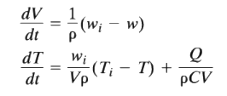

The frequency domain equations for the same would be:

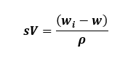

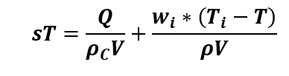

**Observations:**

